CA线上办理网址：[https://www.fjdzyz.com/project/topage.do?page=ztb/npygzc/page/yw/y](https://www.fjdzyz.com/project/topage.do?page=ztb/npygzc/page/yw/yw)

[所需材料：](https://www.fjdzyz.com/project/topage.do?page=ztb/npygzc/page/yw/yw)

[1、数字印章申请表](https://www.fjdzyz.com/project/topage.do?page=ztb/npygzc/page/yw/yw)

[2、电子印章申请表](https://www.fjdzyz.com/project/topage.do?page=ztb/npygzc/page/yw/yw)

[3、营业执照复印件（加盖公章）](https://www.fjdzyz.com/project/topage.do?page=ztb/npygzc/page/yw/yw)

[4、经办人身份证复印件（加盖公章）](https://www.fjdzyz.com/project/topage.do?page=ztb/npygzc/page/yw/yw)

[5、汇款凭证（加盖公章）](https://www.fjdzyz.com/project/topage.do?page=ztb/npygzc/page/yw/yw)

[6、法人身份复印件（加盖公章）](https://www.fjdzyz.com/project/topage.do?page=ztb/npygzc/page/yw/yw)

[汇款账户信息：](https://www.fjdzyz.com/project/topage.do?page=ztb/npygzc/page/yw/yw)

[公司名称：福建凯特信息安全技术有限公司](https://www.fjdzyz.com/project/topage.do?page=ztb/npygzc/page/yw/yw)

[开户银行：兴业银行福州五四支行](https://www.fjdzyz.com/project/topage.do?page=ztb/npygzc/page/yw/yw)

[公司账号：117060101400010383](https://www.fjdzyz.com/project/topage.do?page=ztb/npygzc/page/yw/yw)

[（请对公转账，办理总公司CA不支持使用分公司账号转账）](https://www.fjdzyz.com/project/topage.do?page=ztb/npygzc/page/yw/yw)

[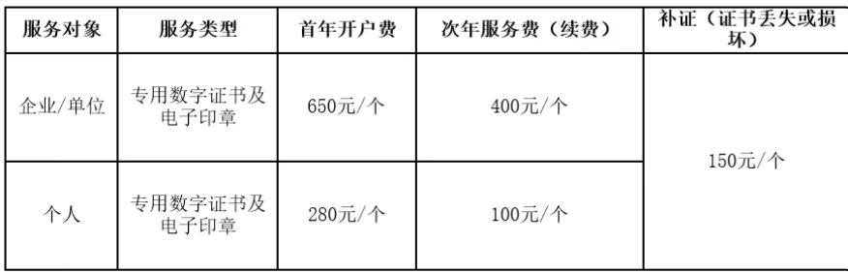](https://www.fjdzyz.com/project/topage.do?page=ztb/npygzc/page/yw/yw)

[供应商需办理企业CA+个人（法人）CA=930元](https://www.fjdzyz.com/project/topage.do?page=ztb/npygzc/page/yw/yw)

[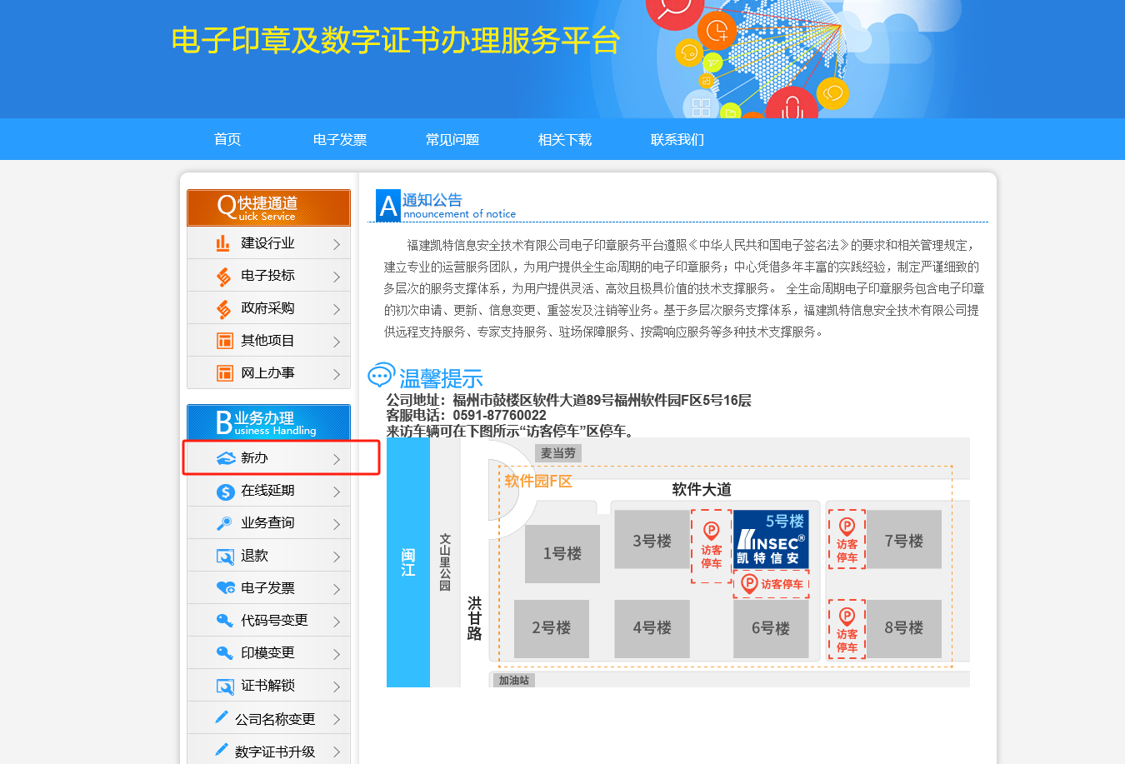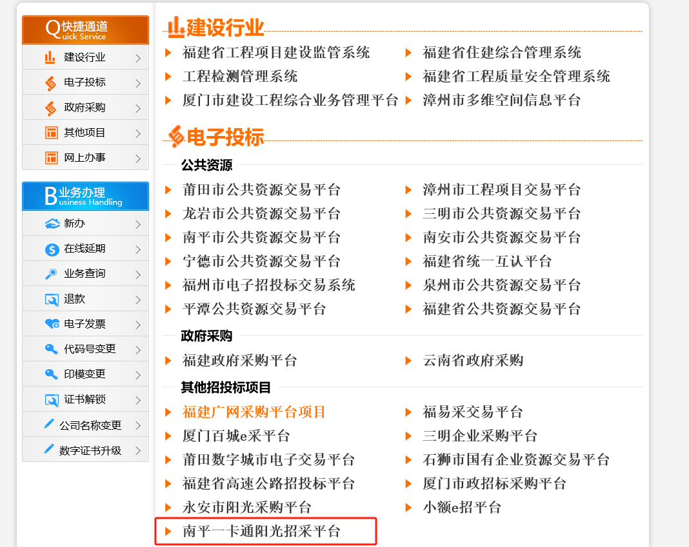](https://www.fjdzyz.com/project/topage.do?page=ztb/npygzc/page/yw/yw)

下载相关材料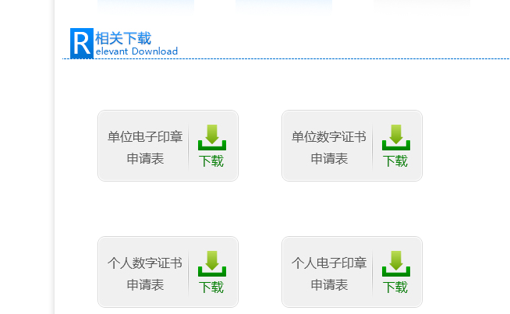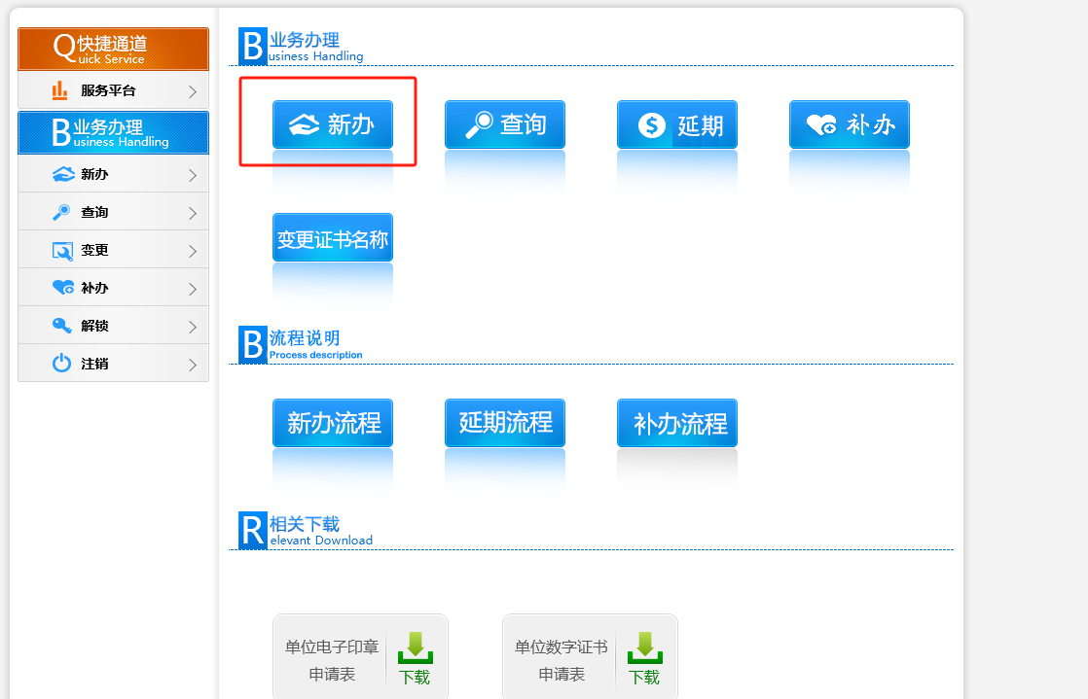

填写办理材料注意事项：

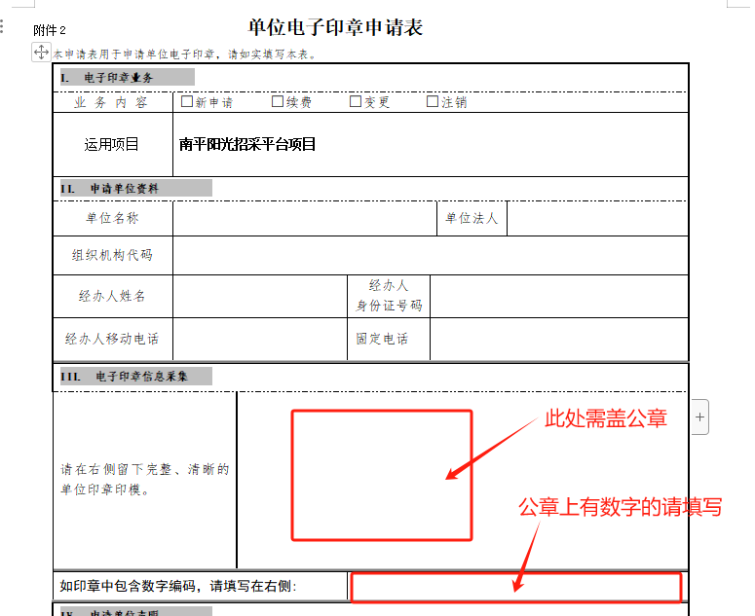

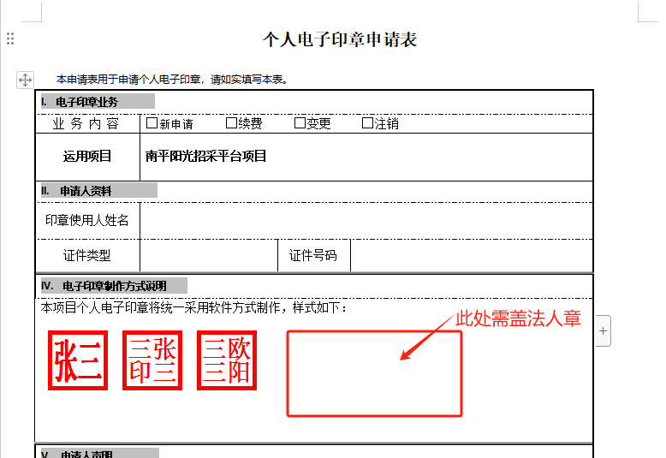

发票需要CA办理完成后线上领取[www.fjdzyz.com](http://www.fjdzyz.com)

